**Day 8**

1. Create view vw_updatable_products (use same query whatever I used in the training)

Try updating view with below query and see if the product table also gets updated.

Update query:

UPDATE updatable_products SET unit_price = unit_price * 1.1 WHERE units_in_stock < 10;

**Ans**:

CREATE VIEW vw_updatable_products AS

SELECT

product_id,

product_name,

unit_price,

units_in_stock,

discontinued

FROM products

WHERE discontinued = 0

WITH CHECK OPTION;

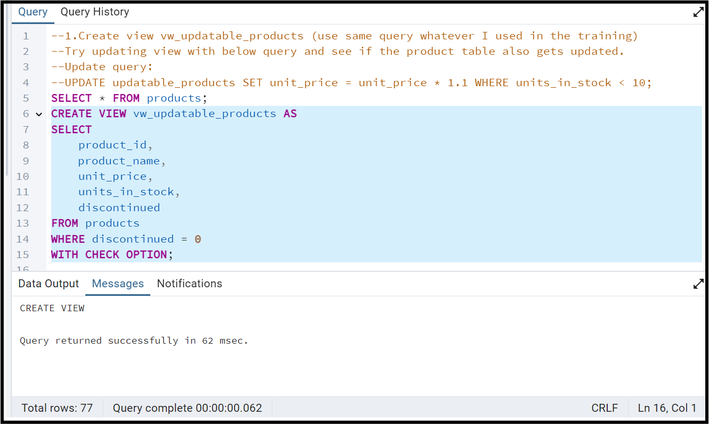

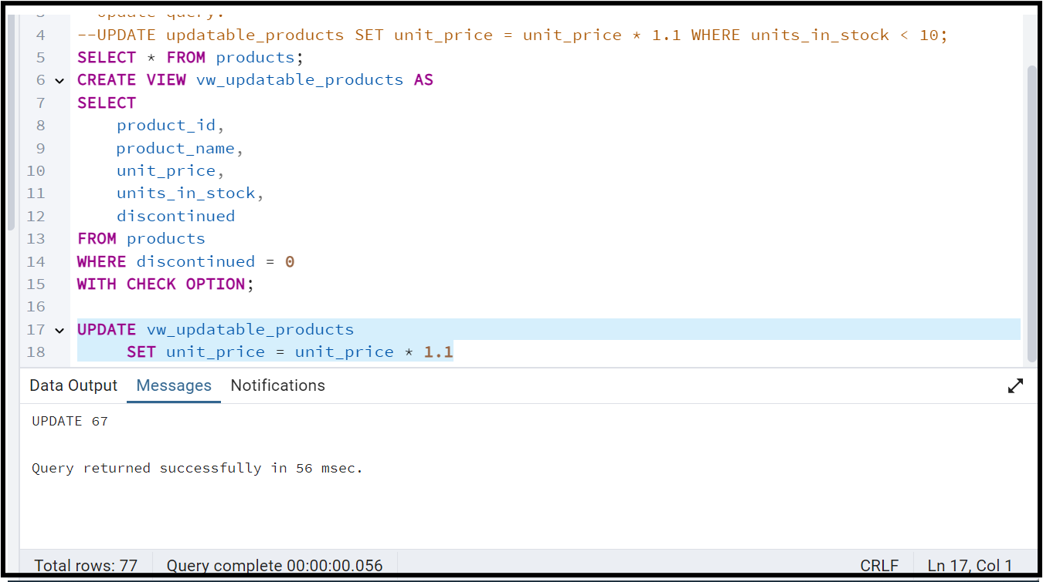

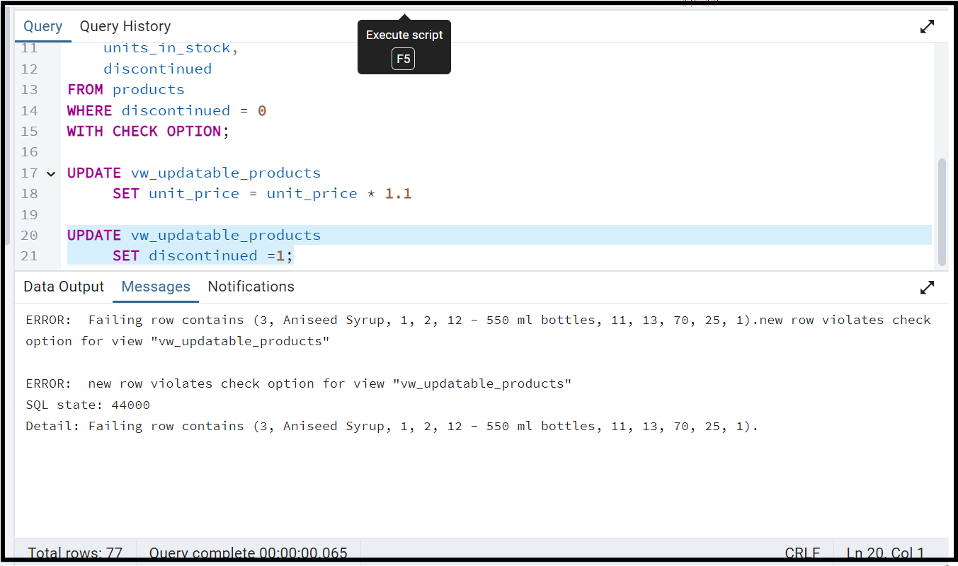

2. Transaction:

Update the product price for products by 10% in category id=1

Try COMMIT and ROLLBACK and observe what happens.

UPDATE products

SET unit_price = unit_price*1.10

WHERE category_id =1;

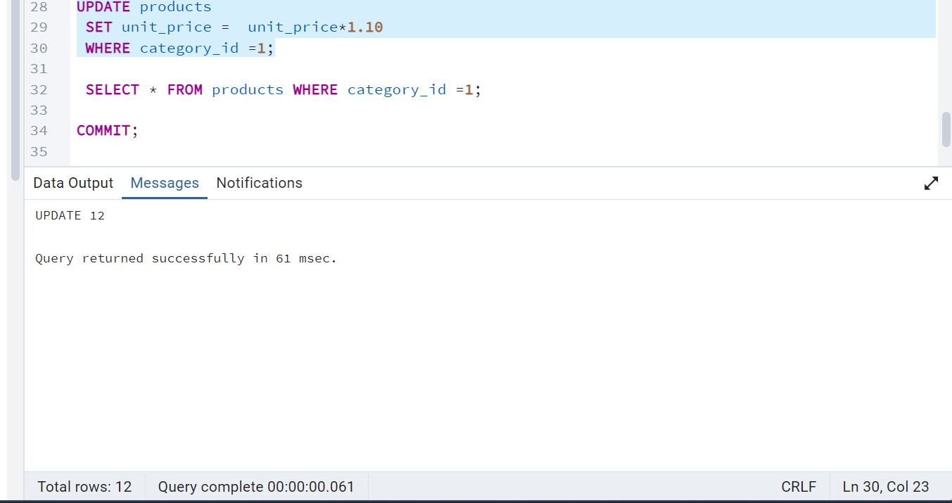

SELECT * FROM products WHERE category_id =1;

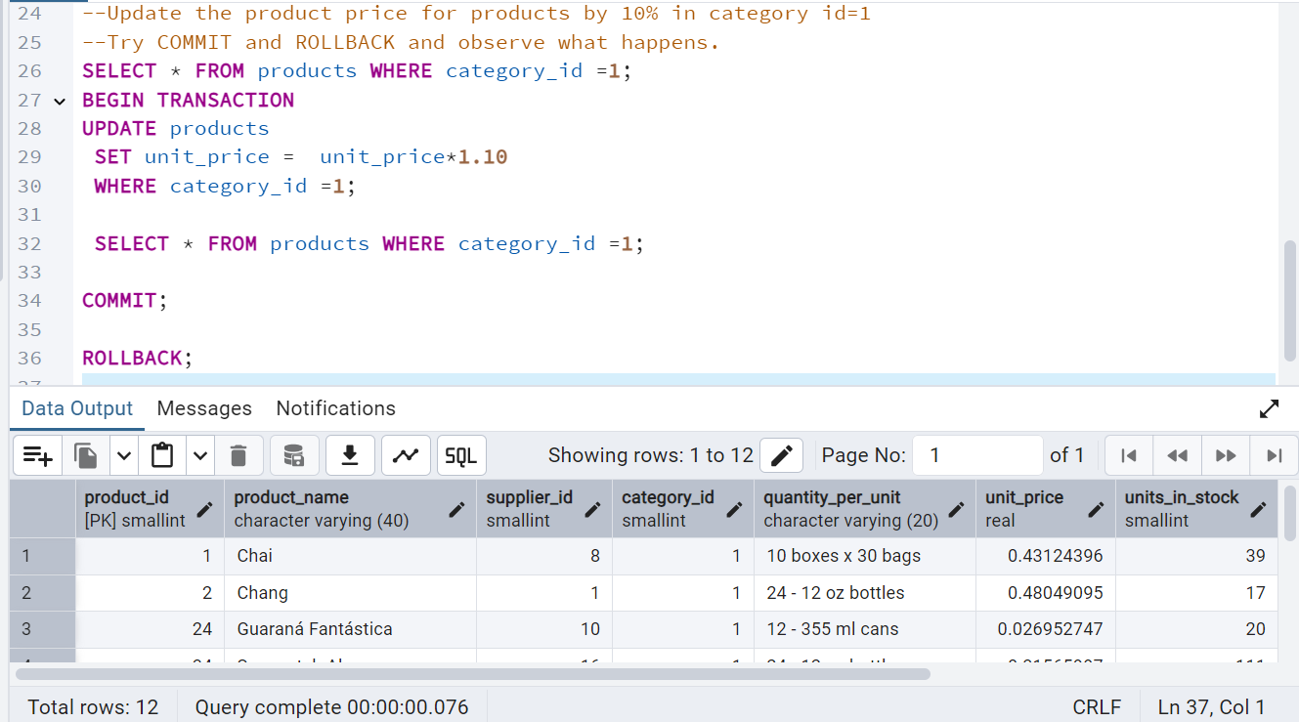

3. Create a regular view which will have below details (Need to do joins):

Employee_id,

Employee_full_name,

Title,

Territory_id,

territory_description,

region_description

Ans:

CREATE VIEW vw_employee_territories_region AS

SELECT e.employee_id,

e.first_name ||' '||e.last_name AS Employee_full_name,

e.title,

et.territory_id,

t.territory_description,

r.region_description

FROM employees e

INNER JOIN employee_territories et ON e.employee_id = et.employee_id

INNER JOIN territories t ON et.territory_id = t.territory_id

INNER JOIN region r ON t.region_id = r.region_id;

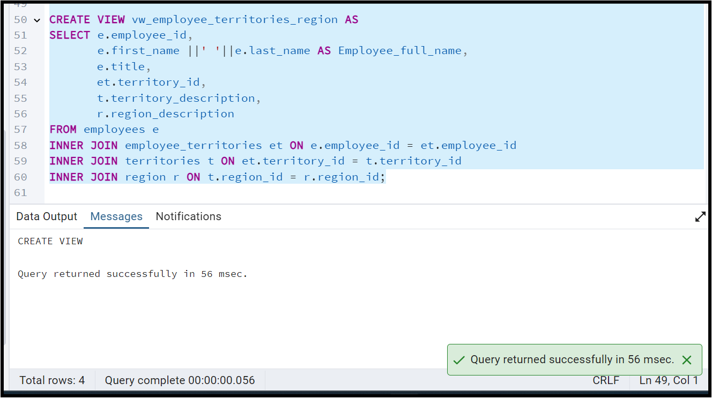

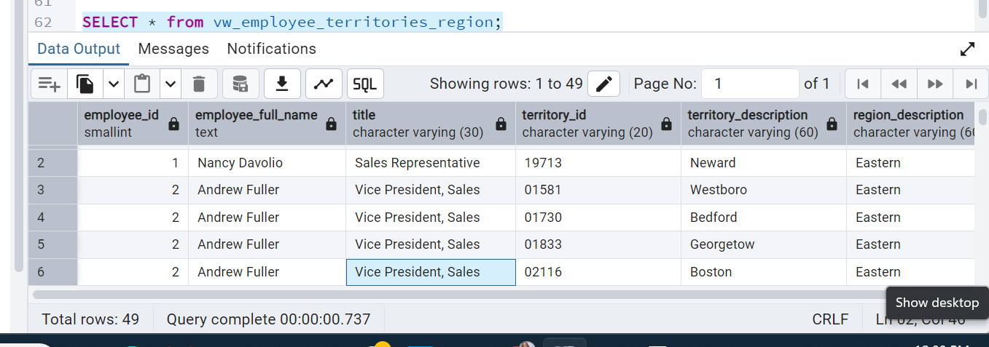

4. Create a recursive CTE based on Employee Hierarchy

**Ans**:

WITH RECURSIVE cte_employee_hierarchy as (

SELECT employee_id,

first_name,

last_name,

reports_to,

0 AS level

FROM employees e

WHERE reports_to IS NULL

UNION ALL

SELECT e.employee_id,

e.first_name,

e.last_name,

e.reports_to,

eh.level+1

FROM employees e

JOIN

cte_employee_hierarchy eh

ON

eh.employee_id = e.reports_to

)

SELECT * FROM cte_employee_hierarchy

ORDER BY level;

